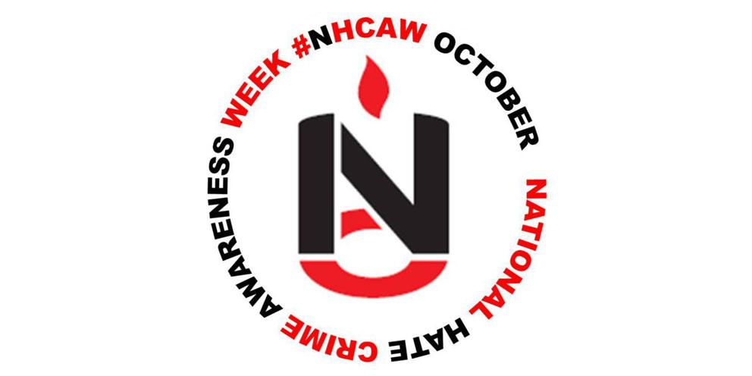

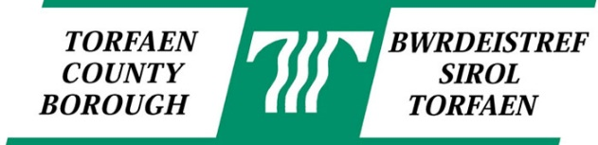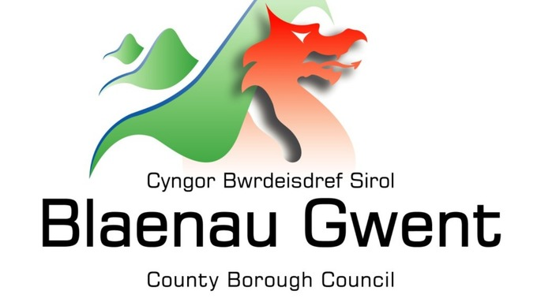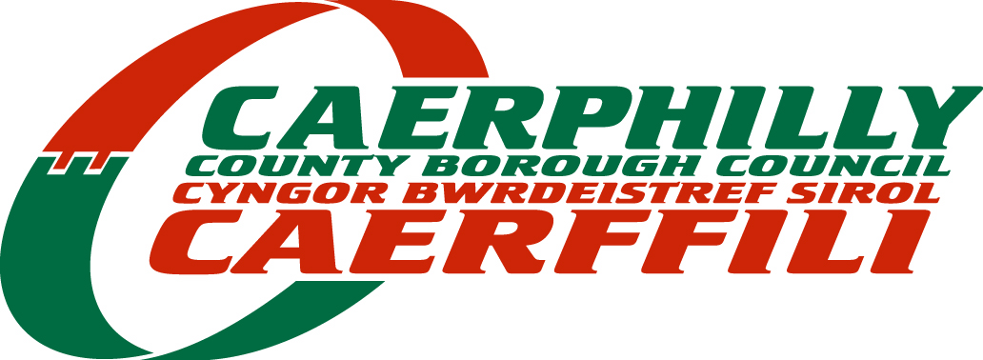

Hate Crime Awareness Week (HCAW) 2021
Funding Application Form

West Gwent local authority areas (Torfaen, Blaenau Gwent, and Caerphilly) have been provided additional funding from Welsh Government to raise awareness and plan activities during hate crime awareness week (HCAW).

Local Authorities across West Gwent would like to further support local community networks to challenge and respond to hate crime and invite bids from community groups for amounts up to £1000.

Hate Crime awareness week will run from 9th – 16th October. Previous HCAW activities have included:

- A youth club activity exploring food and the different cuisines that we share and love
- A hate Crime Rap track produced in a professional studio
- Arts and Crafts activities raising awareness on hate crime reporting
- An externally commissioned social media campaign and animation
- A public engagement event aimed at challenging negative perceptions of asylum seekers and refugees coming to Gwent
- A community cup football tournament and cultural celebration to support cohesion and integration
- Production of all Wales hate crime materials in range of languages

Organisations are not limited to hate crime specific activities. We would really welcome applications from organisations who champion diversity and inclusion when planning their activities.

All successful applications will be required to meet the Regional Community Cohesion Officer via teams/zoom before the start of the project to discuss the activity and to offer additional guidance/support.

1. | Name and full address of community group/organisation:
2. | Name of key contact:
3. | Email address:
4. | Telephone Number:
5. | What event/activity are you planning during HCAW in 2021? (in no more than 500 words)
6. | How will your event/activity meet one or more of the following objectives? (in no more than 300 words)  - Encouraging reporting of hate crime  - Challenging Racism and the rise of disability hate crime  - Championing Diversity and Inclusion  - Promoting inclusion and equality of opportunity  - Building confidence particularly amongst minority groups to report hate crime and other community issues  - Tackling hate in the late night economy (abuse directed at shop, bar, and restaurant workers and taxi drivers)
7. | How will you promote your event/activity?
8. | Where and when are your activities going to take place?  (Please note, your event/activity should be on or around HCAW )
9. | Total Project Cost:
10. | Amount requested from this  funding:  (a maximum of £1000 for events/activity)

Bank or Building Society Details
If your application is successful the money requested will be paid into your organisation’s host bank account after your HCAW activity.

After your HCAW activity, a short evaluation form will be sent out to help measure the success of the activity. All payments will be made on receipt of evaluation form.

Name and address of Bank:
Bank Account Number

Sort Code

Name (Print clearly)… ….. Position ……

Signature :… Date: ………..

Please send your completed application form via email to: michael.morgan@torfaen.gov.uk
no later than 5pm on Friday 10th September 2021.

For office use only:

Date application received ………………………………….…………………………………………...

Date of panel meeting …………………………………………………………………………………..

Date of decision to applicant ……………………………………………………………………………

